**Charotar University of Science and Technology**

**Devang Patel Institute of Advance Technology and Research**

**Department of Computer Engineering**

|  |  |  |  |  |  |
| --- | --- | --- | --- | --- | --- |
| **Student ID** | **:** | **18DCE115** | **Student Name** | **:** | **KASHYAP SHAH** |
| **Subject Code** | **:** | **CE246** | **Subject Name** | **:** | **DATABASE MANAGEMENT SYSTEM** |
| **Date of exam** | **:** | **29-05-2020** | **Semester** | **:** | **4th Semester** |

**Definition:**

There is a warehouse of AMart. Create a table to manage the items available in AMart warehouse

Create a table: Warehouse_data

Table: warehouse_data

Field Name Data type

Item_id Varchar2(10)

Item_name Varchar2(20)

Price Number(8,2)

Insert minimum 5 records.

Create a field called Quantity. Take the data of quantity from user and store it into the table.

When a new item imported, check whether the item is available in the given table or not. If it’s

available, then update the quantity and if the item is not available then insert a new record into

warehouse_data table.

At last, create a function to display the total price.

**Solution (code & screenshot):**

CREATE TABLE Warehouse_data(item_id varchar2(10), item_name varchar2(20), price number(8,2))

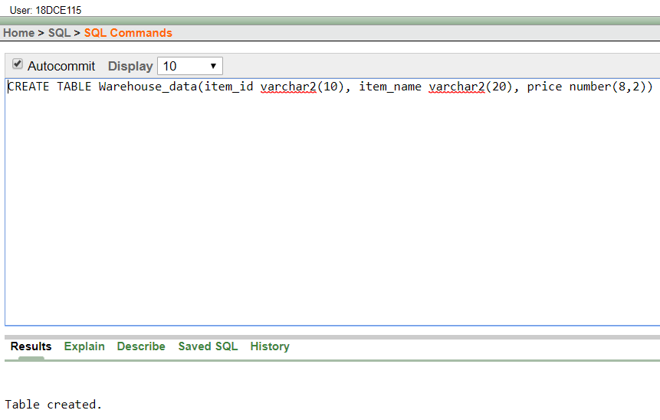

INSERT INTO Warehouse_data VALUES(1, 'TV', 1000)

INSERT INTO Warehouse_data VALUES(2, 'Laptop', 2500)

INSERT INTO Warehouse_data VALUES(3, 'Mobile', 1300)

INSERT INTO Warehouse_data VALUES(4, 'Macbook', 5400)

INSERT INTO Warehouse_data VALUES(5, 'Mouse', 500)

desc Warehouse_data

SELECT * FROM Warehouse_data

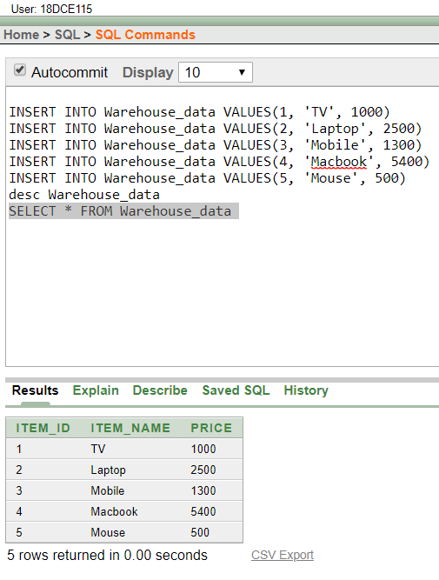

ALTER TABLE Warehouse_data ADD quantity number(5)

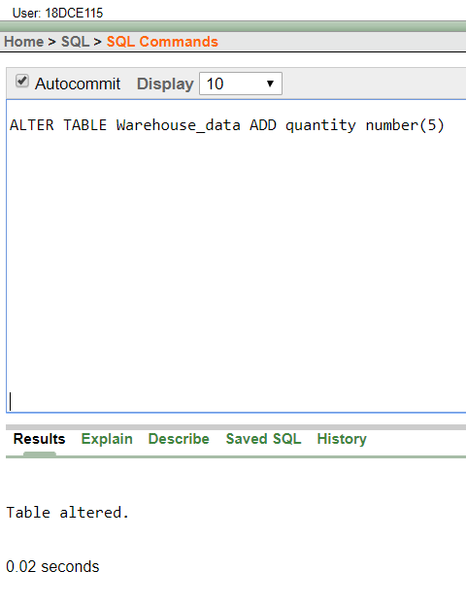

Create or replace function add_quan(id varchar2, quantity2 number) return number

Is

Begin

IF id<6 AND id>0 THEN

UPDATE Warehouse_data SET quantity=quantity2 WHERE item_id=id;

Return(quantity2);

ELSE

dbms_output.put_line('Does not exist');

Return(quantity2);

END IF;

End;

declare

quantity2 number;

i number;

q number;

begin

i:=:id;

q:=:quantity;

quantity2:=add_quan(i,q);

dbms_output.put_line('Added Quantity: '||quantity2);

end;

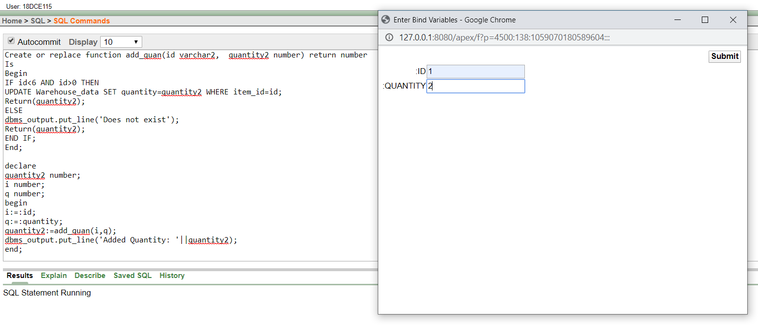

CREATE OR REPLACE PROCEDURE update_price(id IN varchar2, price IN number,new_price OUT number)

Is

Begin

UPDATE Warehouse_data SET price=price*quantity where item_id=id;

select price into new_price from Warehouse_data where item_id=id;

End;

declare

new_price number;

i number;

p number;

begin

i:=:id;

p:=:price;

update_price(i,p,new_price);

dbms_output.put_line(new_price);

end;

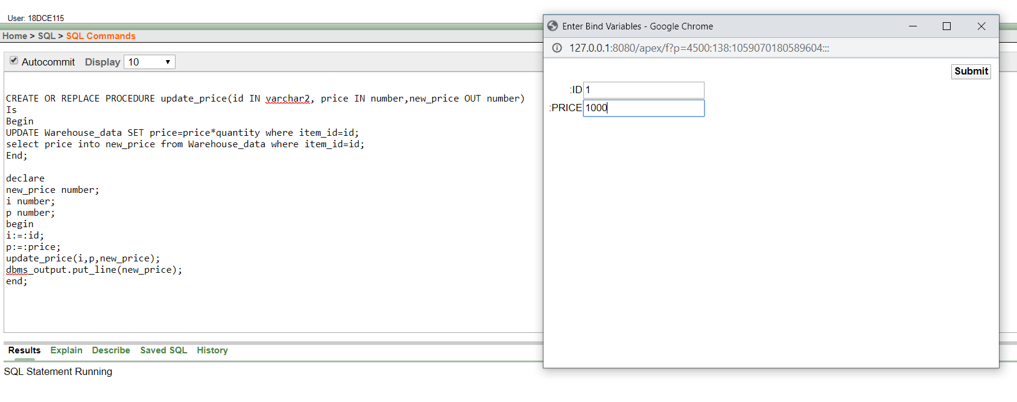

Create or replace function total(p number) return number

Is

a Warehouse_data.price%type;

Begin

SELECT sum(price) INTO a FROM Warehouse_data;

Return(a);

End;

DECLARE

cost Warehouse_data.price%type;

BEGIN

cost:=total(1);

DBMS_OUTPUT.PUT_LINE('total cost: '||cost);

END;

